http://cdn2.hubspot.net/hub/252575/file-222049980-jpg/images/linkedin_in_icon_5incmyk1.jpg?t=1422623113978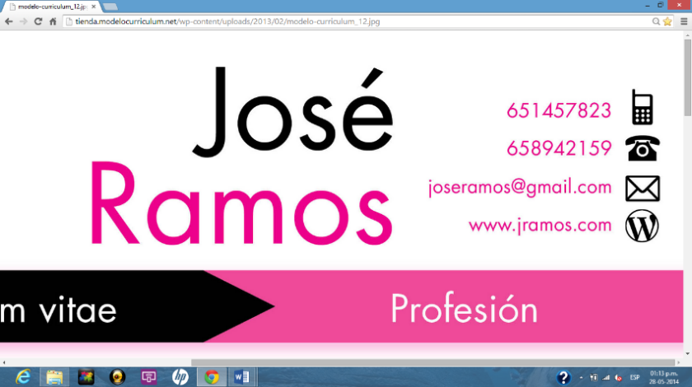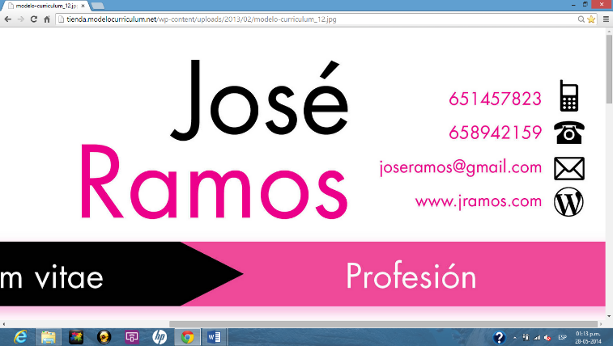

*Business management professional with vast expertise in customer journey process optimization, as well as analysis and implementation of business processes tech tools and improvements. Demonstrating strong leadership skills while working in international and dynamic environments. Career goal: continue driving successful results leading implementation teams in Business innovation projects~~.~~*

* Data analysis and management**.**
* **Project planning and management.**
* **Marketing and sales processes automation.**
* **Hubspot** consultant.

**PMI-ACP** course (**Agile** methodologies), March 2018 (Madrid).

Hubspot learning center, **Inbound marketing**, May 2017 (Madrid).

Escuela de Organización Industrial, **E-Commerce** (Madrid, 2015).

International Advertising Bureau, **Digital** **Marketing** (Madrid, 2014).

Kaplan International College, Intensive **English** (Philadelphia, EEUU, 2012).

**Courses**

**Certifications**

- Led, designed and implemented marketing plan of X brand/product/company.

- Contributed in the development of the marketing strategy.

- Analyzed, monitored, maintained market & competitors indicators reports (such market share, Numeric and weighted distribution, etc.)

- Managed and control budget of the area? name area execution.

- Managed marketing campaigns, both on and off.

- Led, designed and executed of promotional campaigns, -results here-

- Developed area’s annual operating plan, including sales, revenue and expenses forecasts.

- Managed and control budget of the area? name area execution.

- Develop and maintained campaigns metrics analysis and reports.

- Managed digital campaign of landing page and banners –“in” or “of”- MARCA.COM y ELMUNDO.ES

- Lead the digital transformation of the business model project?.

- Designed and executed the firm mailing campaigns (using Experian)

**Languages**

English

Spanish

**Hubspot certified – Sales Software, Ibound, Sales Anablement and Ibound Sales**

**Energizer Holdings**

FMCG

Associate Brand Manager

Personal care portfolio

34% market share

Jul 12 – Abr 14

**Right Decision**

Tech Consultancy

Innovation consultant at IE University

May 17 – current

**Unidad Editorial**

Media

Marketing coordinator

MARCA - EL MUNDO

Leader print and digital media company

Nov 14 – May 17

- Evaluate and identify Business Analysis responsible, translating marketing, sales reps and admissions reps needs into processes and workflows functional designs.

- Lead **technology projects implementations** directly related to marketing and sales processes.

- Manage IE University technology integrations of business processes improvements.

- Design, plan, execute and maintain Hubspot, Eventbrite and Microsoft Dynamics integration.

- Manage reports internal requirements.

- Leading and managing specialized teams to enable tech tools and take projects to live.

*Jorge Andrés*

*Castillo Joliveau*

June 12th, 1987

EUDE Business School

**Master Business Administration**

Apr 2014 – Jul 2015

IE Business School

**Innovation for growth (HIOP)**

Feb – Mar 2019

Universidad Católica Andrés Bello

**Business**

Feb 2008 – Jun 2012

Hubspot

PBI

**Skills**

+34 68 414 59 35

[jorge.castillo.joliveau@gmail.com](mailto:jorge.castillo.joliveau@gmail.com)

[www.linkedin.com/in/jorgecastillojoliveau](http://www.linkedin.com/in/jorgecastillojoliveau)

**PROFESSIONAL EXPERIENCE**